Select enmae ,job,deptno from emp where job =’CLERK’;

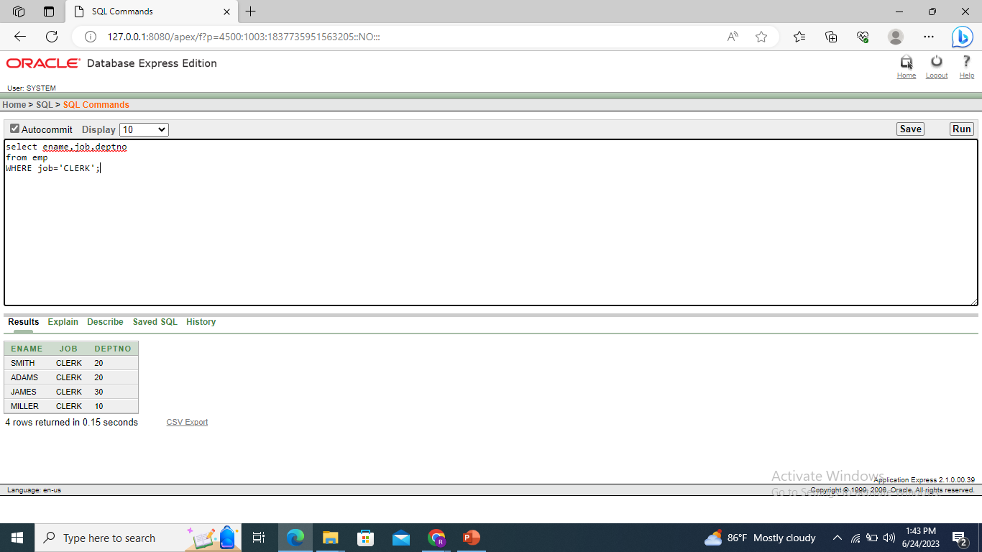

Selert ename ,sal ,comm from emp where sal<=comm;

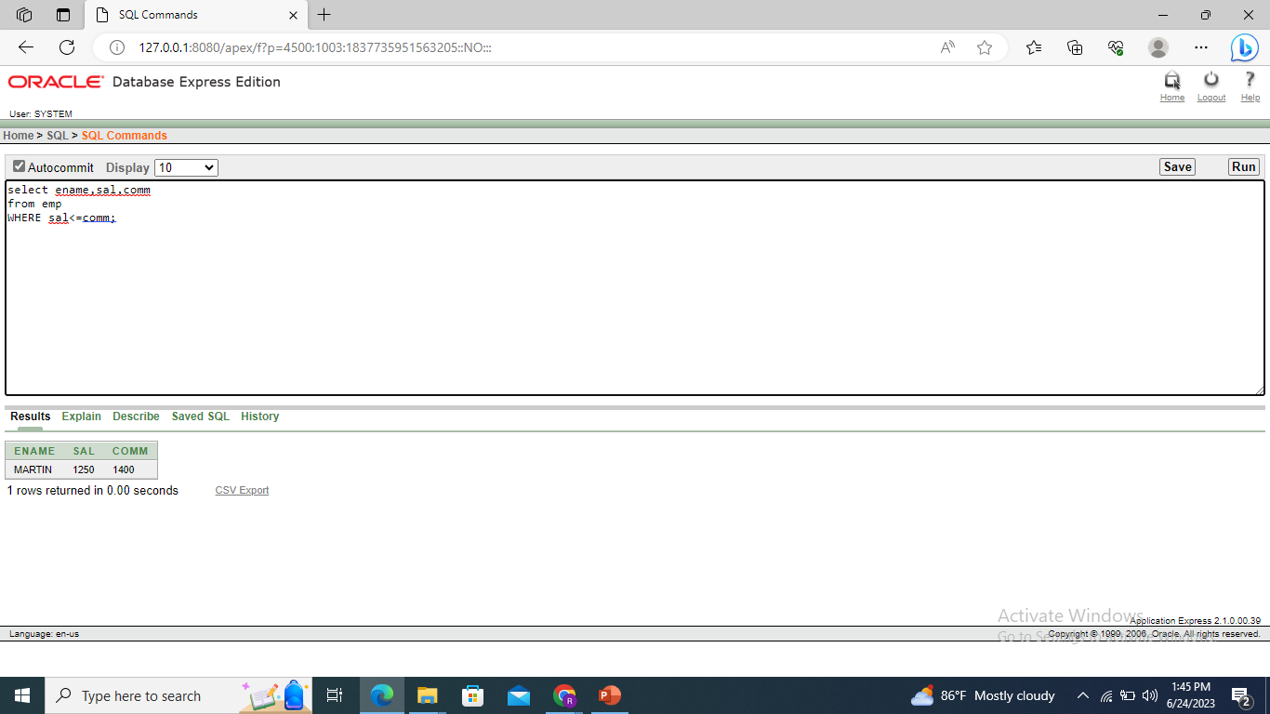

Select ename ,sal from emp where salbetween 1000 and 1500

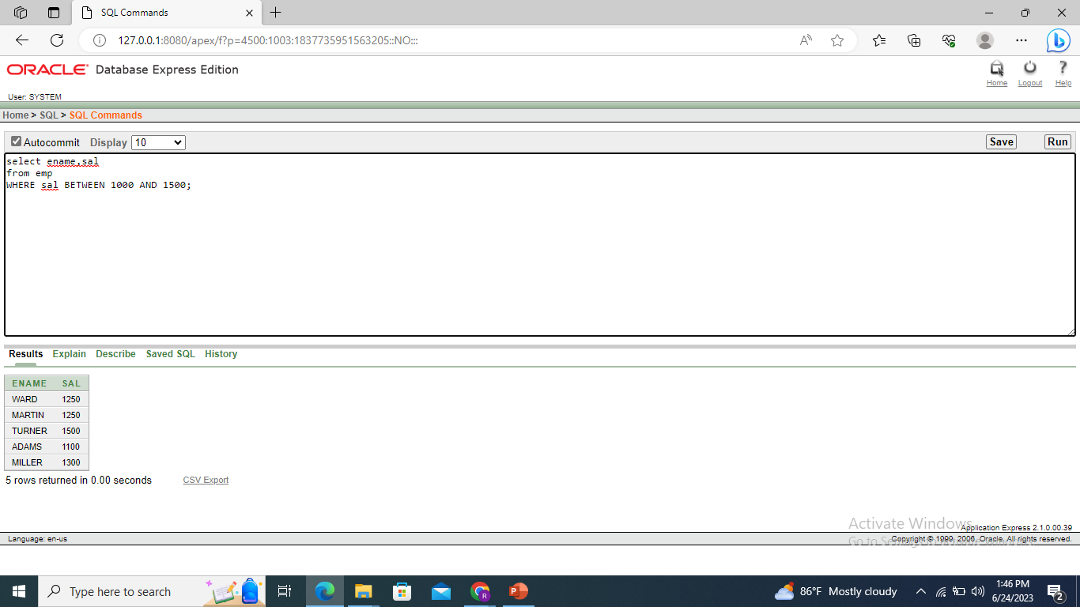

Hselect ename,sal,empno,mgr from emp where mgr in (7902,7666,7788);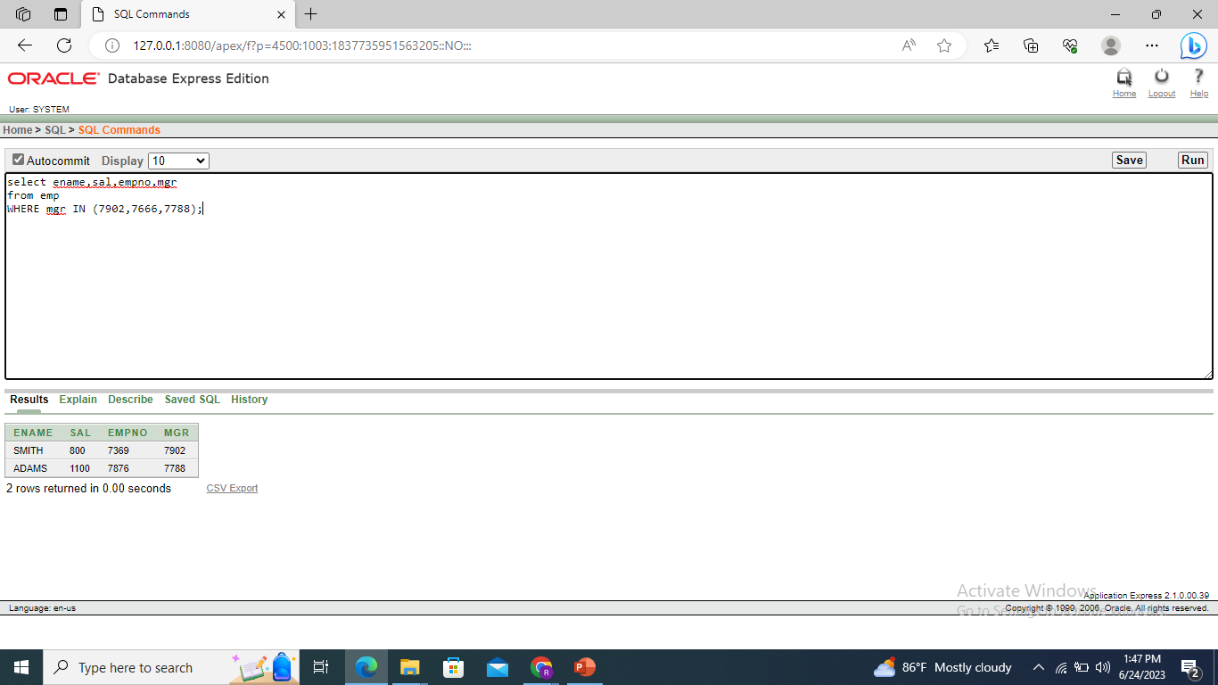

Cselect ename from emp where ename LIKE ‘_A%’;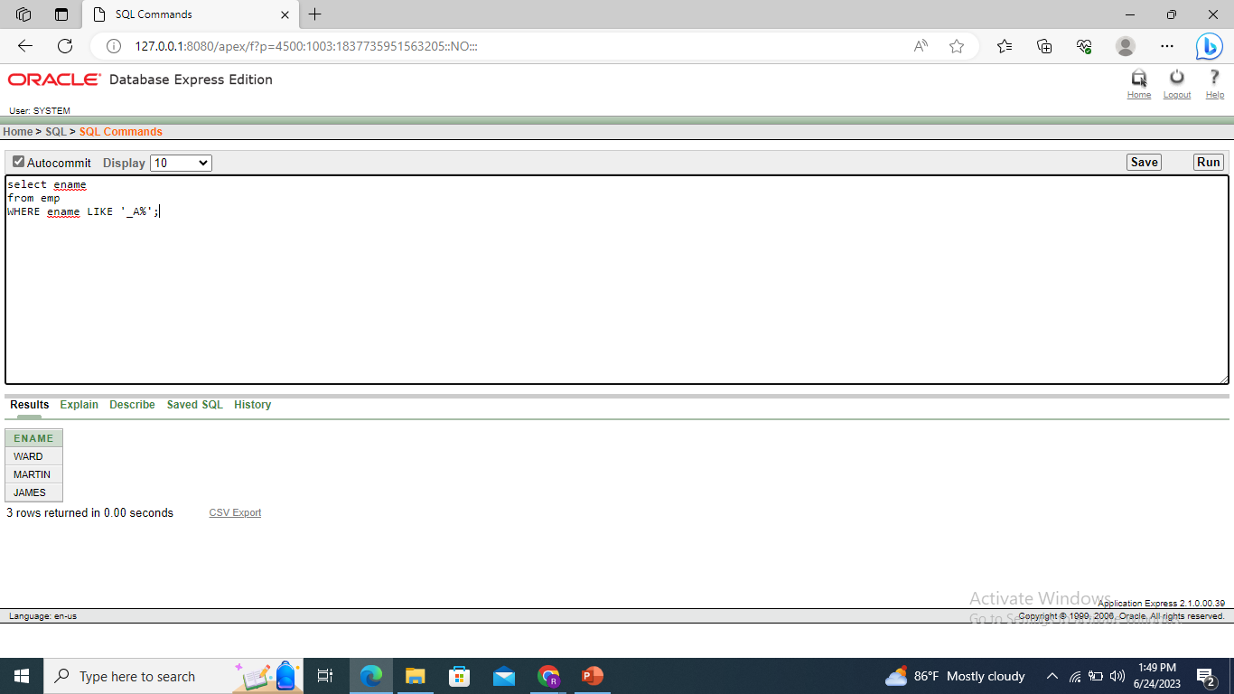

Select ename,mgr from emp where mgr is null;

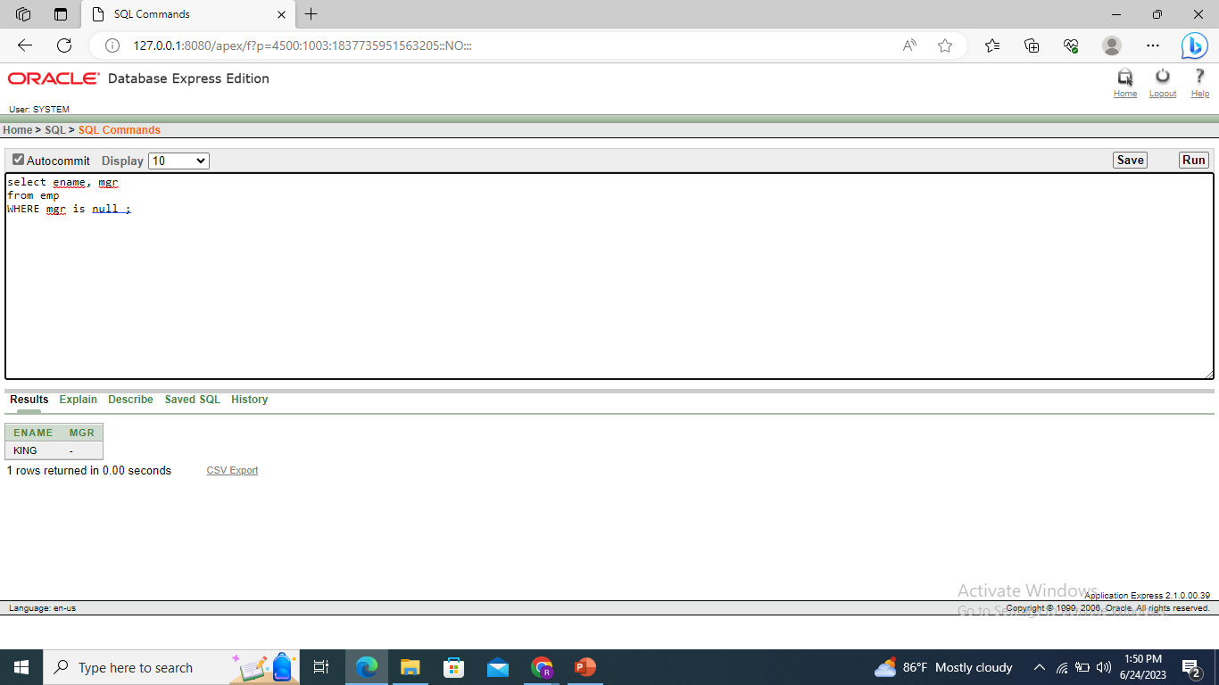

Select ename,empno,job,sal from emp where sal>=1100 AND job=’CLERK’;

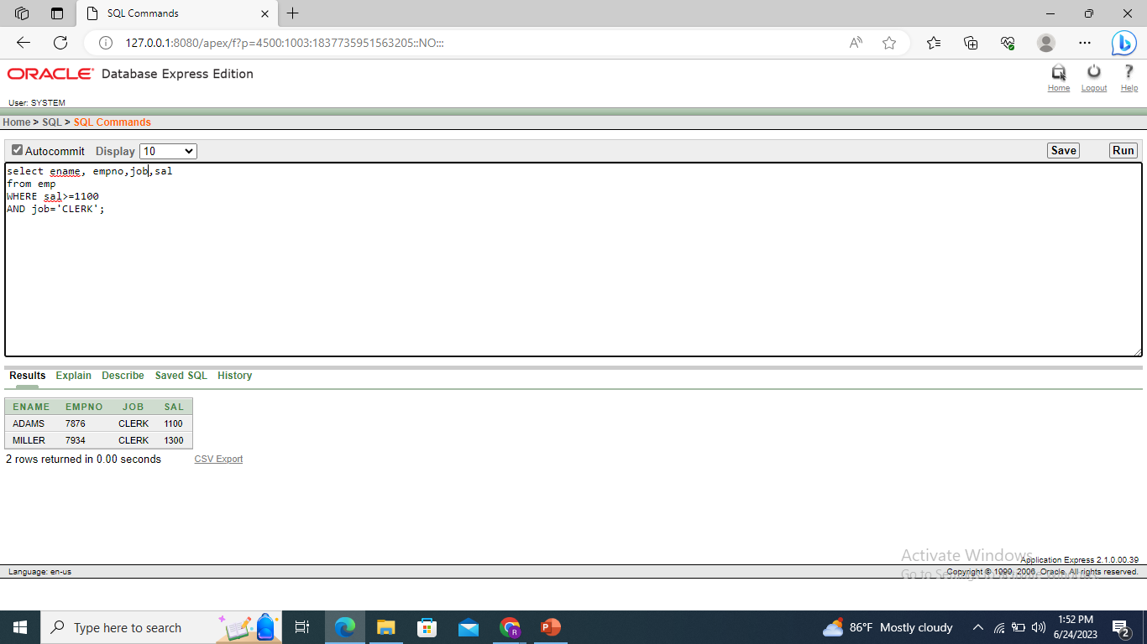

Select ename ,empno,job

From emp where job not in (‘CLERK’,’MANAGER’, ‘ANALYST’);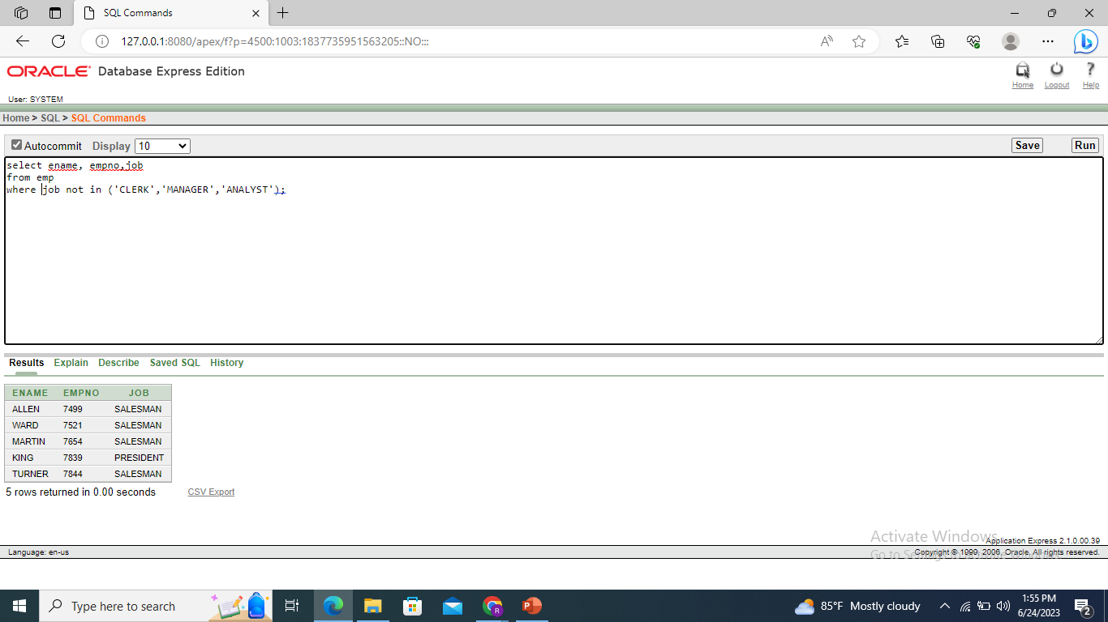

Select ename,empno,job

From emp where (job=’SALESMAN’ or job = ‘PRESIDENT’) and sal>1500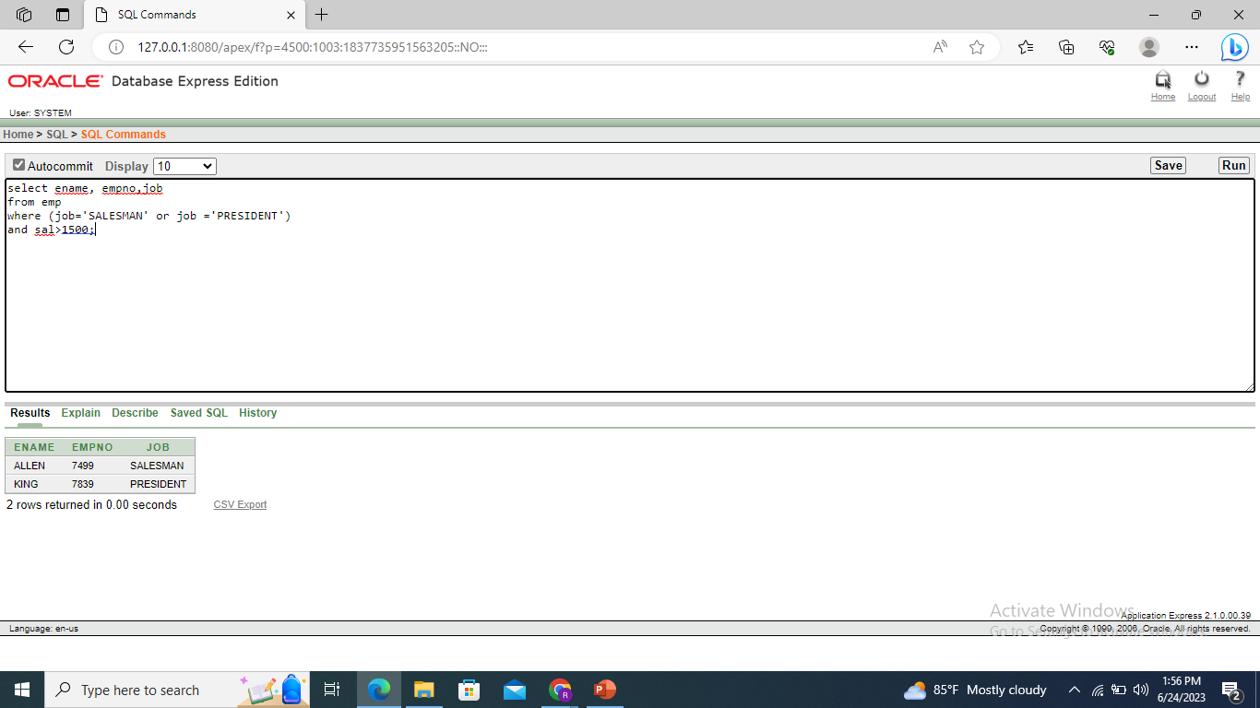

Select ename ,empno,job,sal

From emp where (job= ‘SALESMAN’ or job = ‘PRESIDENT’) and sal>1500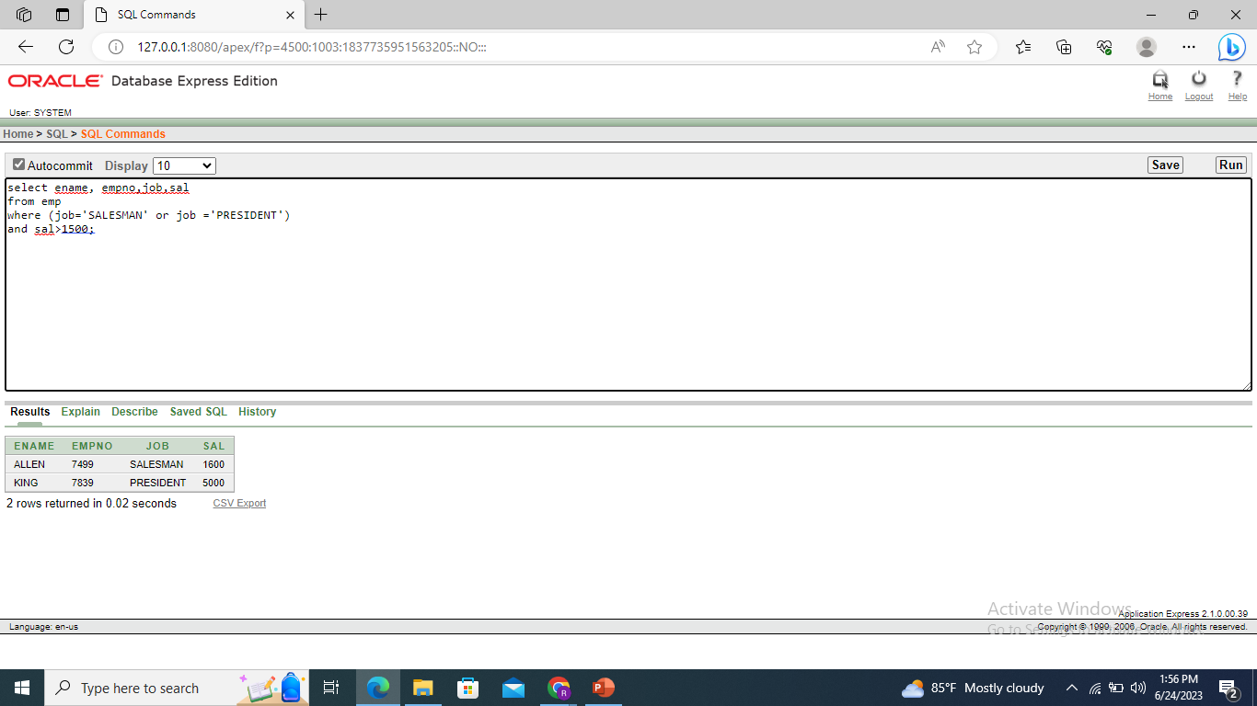

Select ename,job,deptno,hiredate from emp order by hiredate;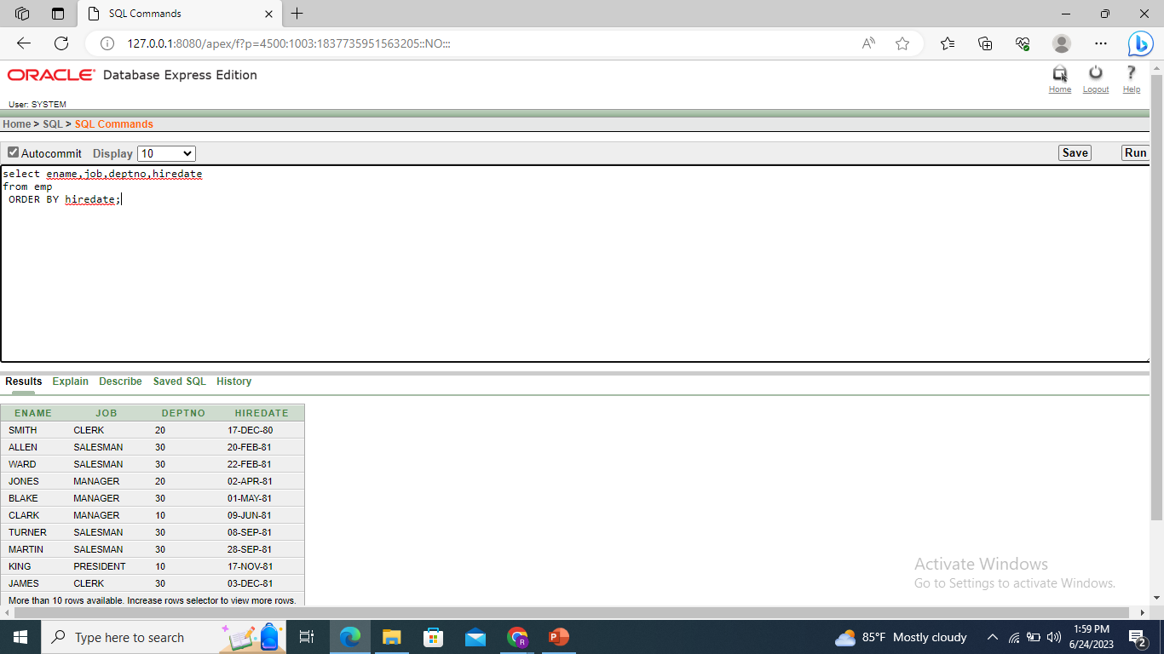

Select ename,job,deptno,hiredate from emp order by hiredate DESC;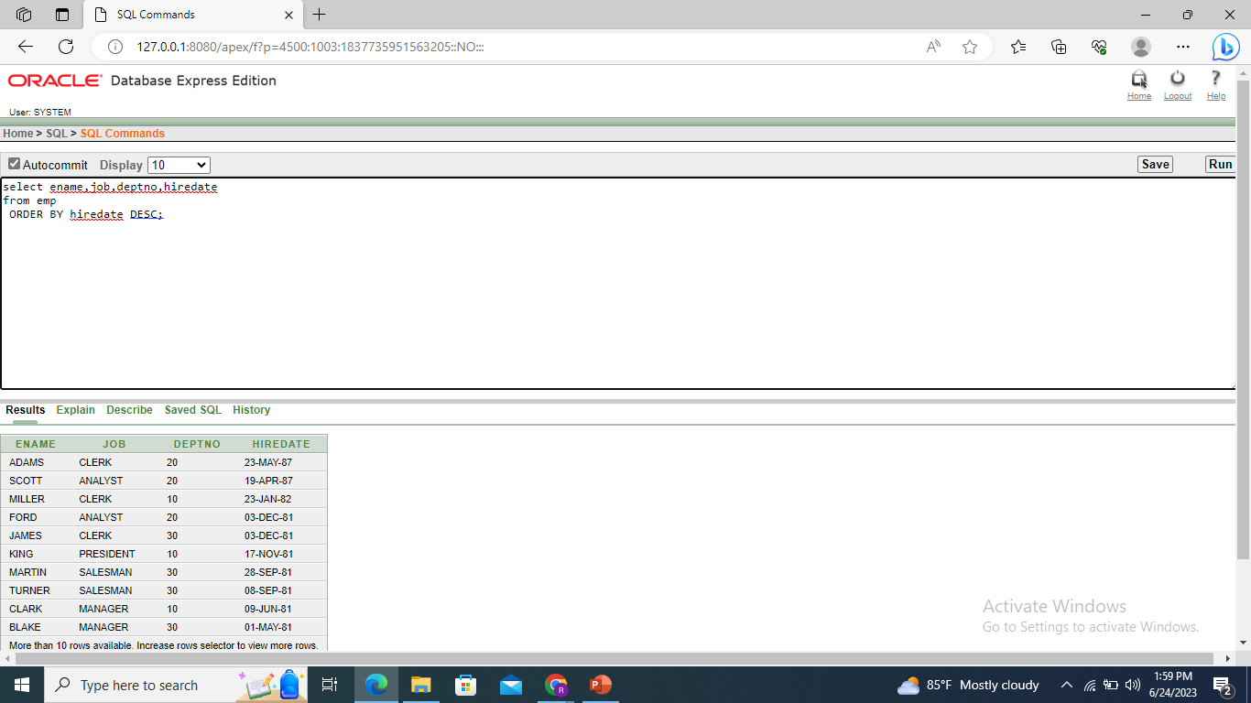

Select ename,empno,job,sal*12 annual from emp order by annsal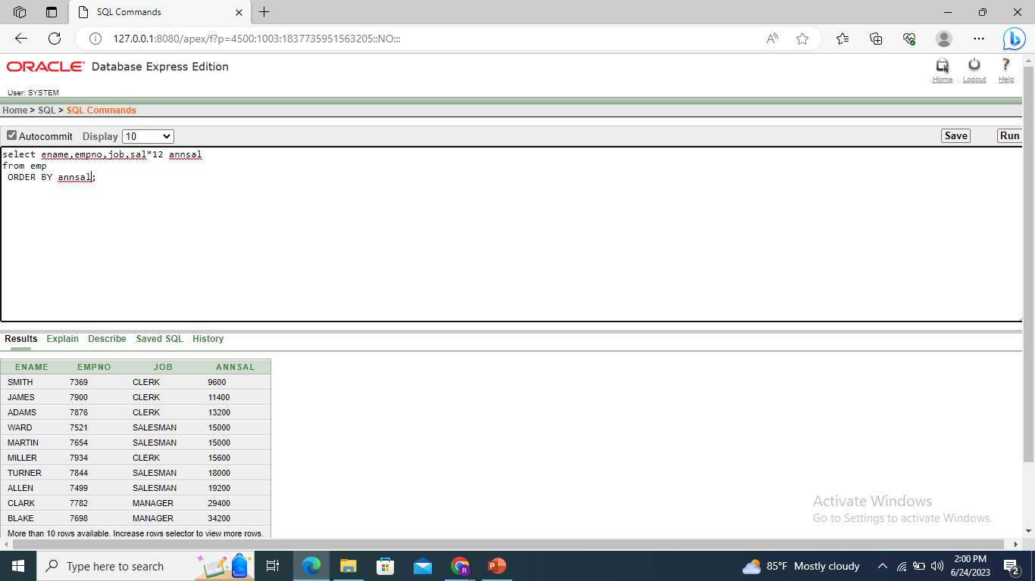

Select ename,deptno,sal from emp Order by deptno,sal,DESC;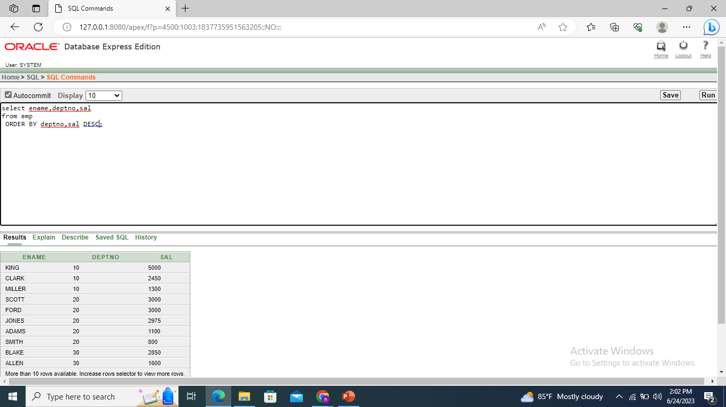

Select ename ,deptno,empno from emp where LOWER (ename)= ‘blake’;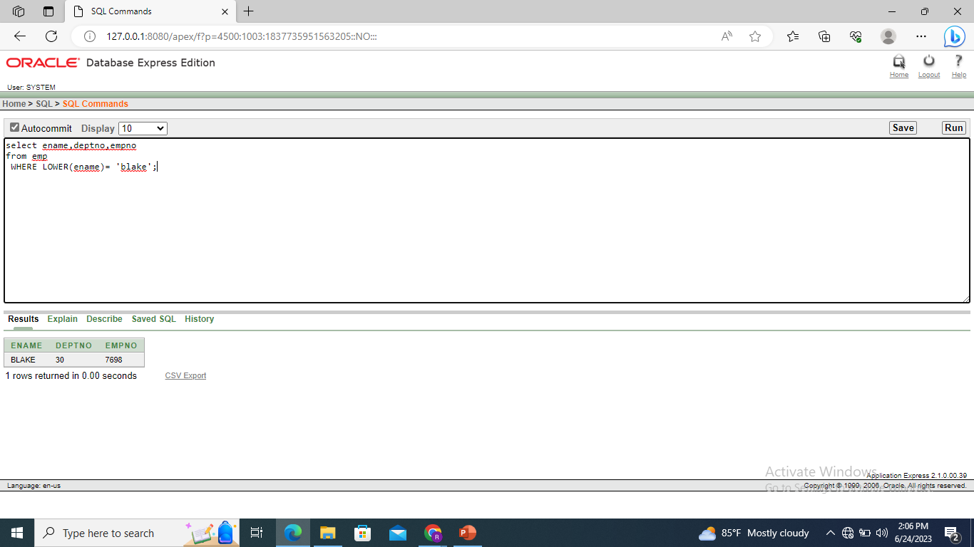

Select ename,concat(ename,job),length(ename),instr(ename,’A’) from emp where SUBSTR(JOB,1,5)= ‘SALES’;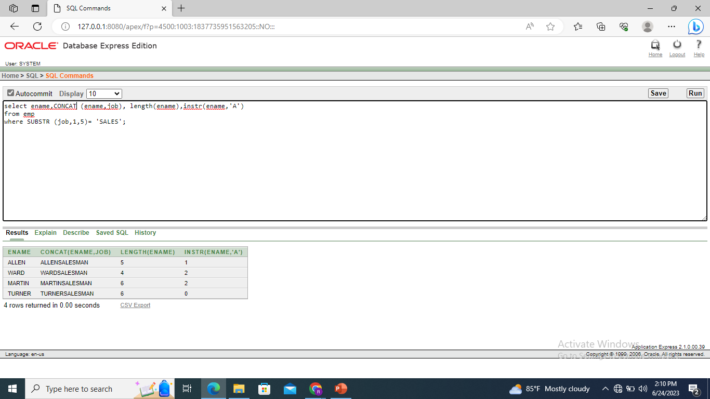

Select ROUND (45.923,2),round(45.923,0),round (45.923,-1) from dual;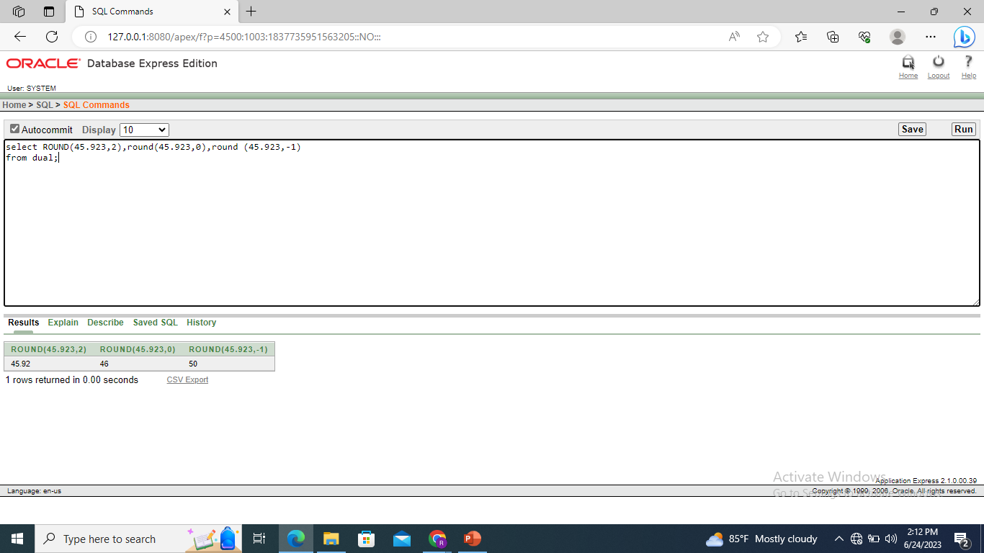

Select ename,sal,comm,MOD(sal,comm) from emp where job=’SALESMAN’;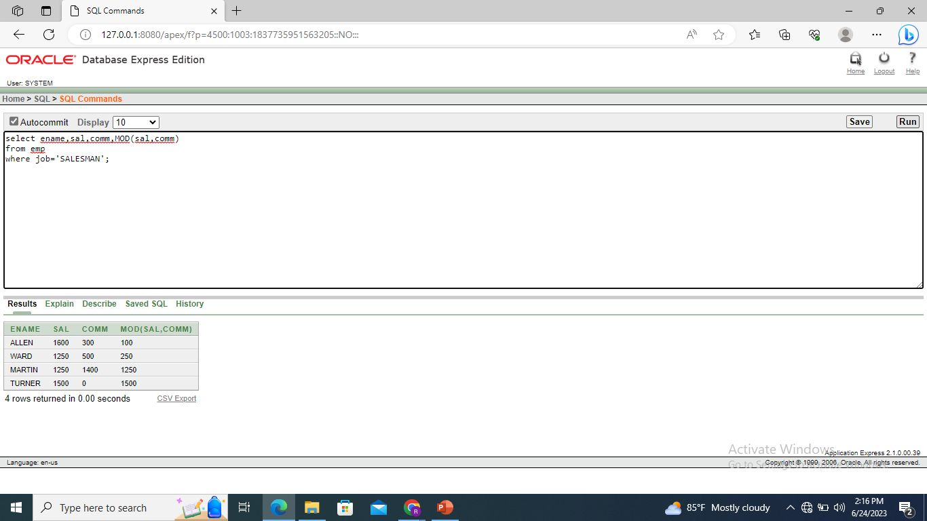

Selecte name,(SYSDATE- hiredate)/7 weeks from emp where deptno = 10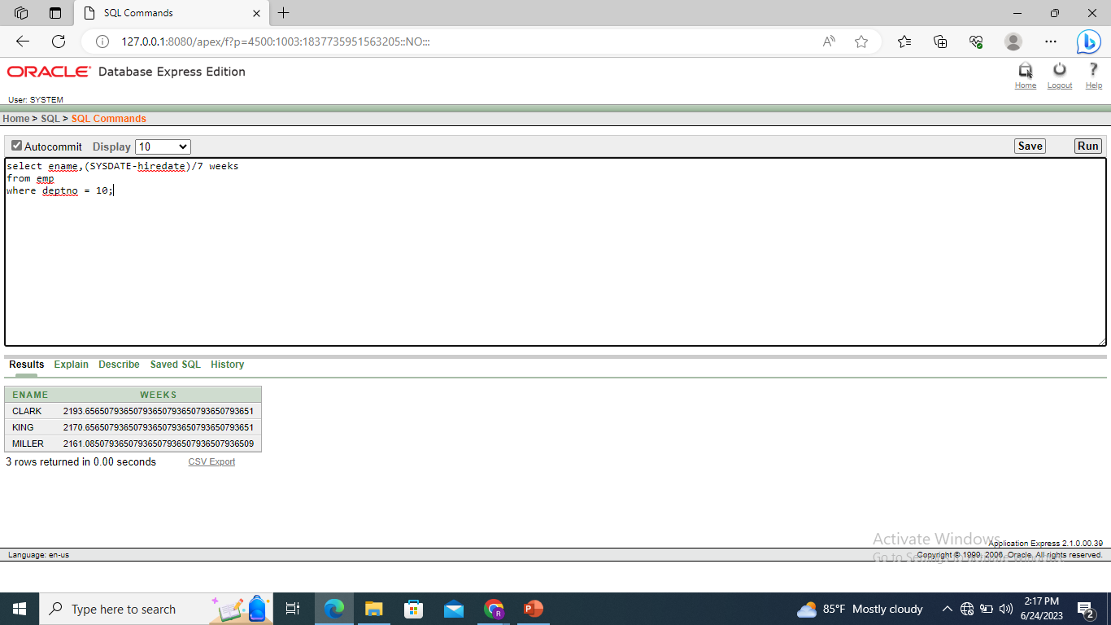

Select ename,TO_CHAR(hiredate, ‘fmDD month YYYY’)HIREDATE FROM emp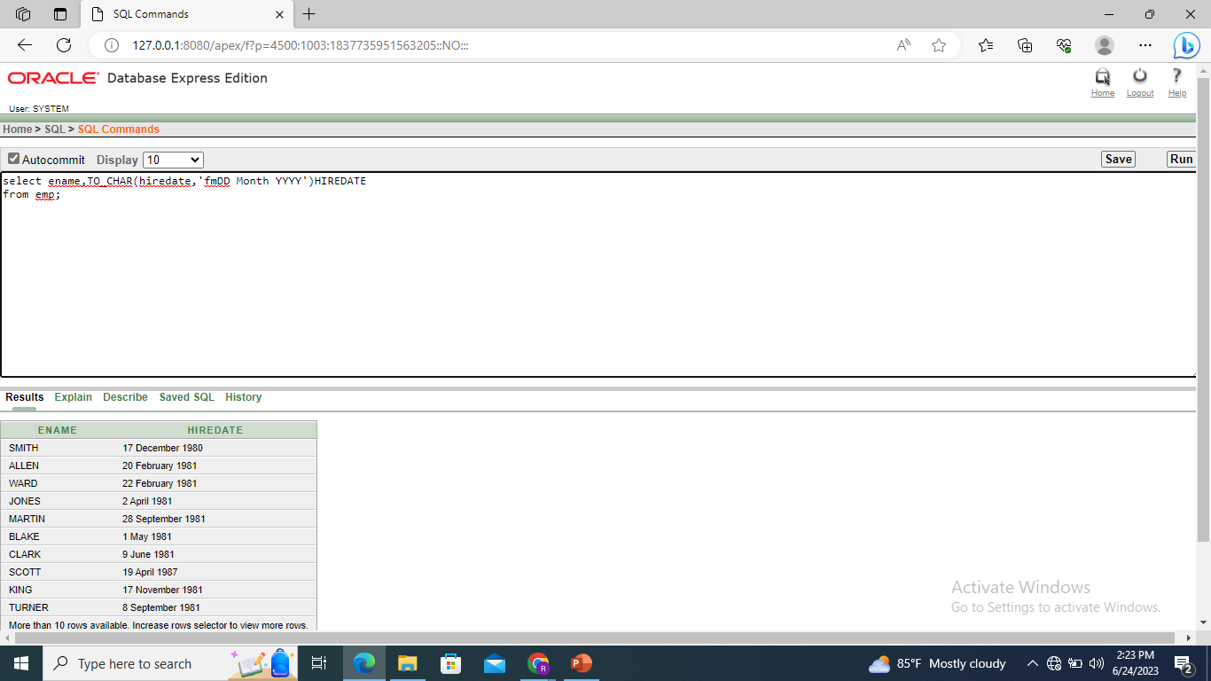

SELECT job,sal,DECODE(JOB,’ANALYST’,sal*1.1, ‘CLERK’, sal*1.15, ‘MANAGER’,sal*1.20,sal) REVISED_SALARY FROM emp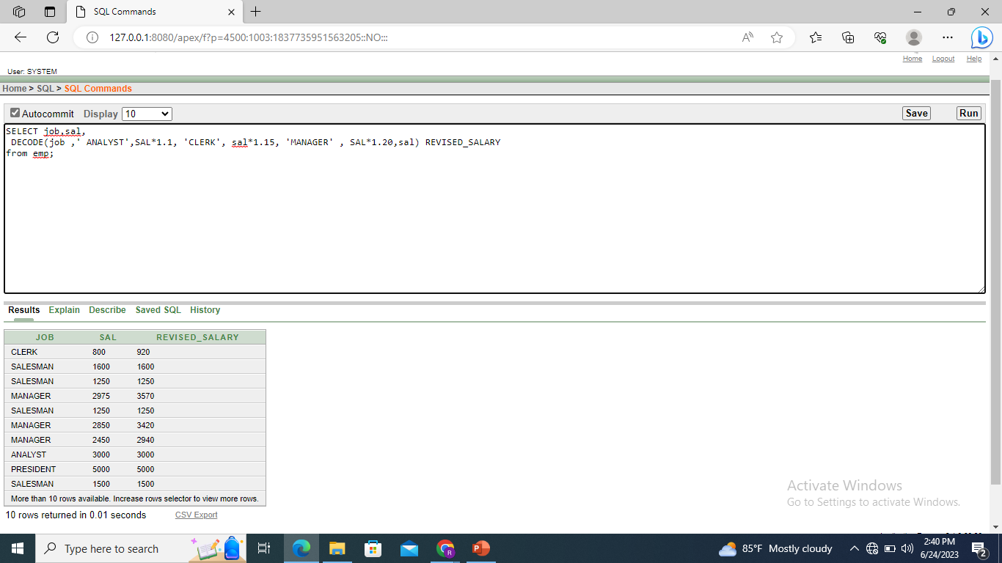

Select ename,NVL(TO_CHAR(mgr),’NO Manager’) FROM emp WHERE MGR is NULL;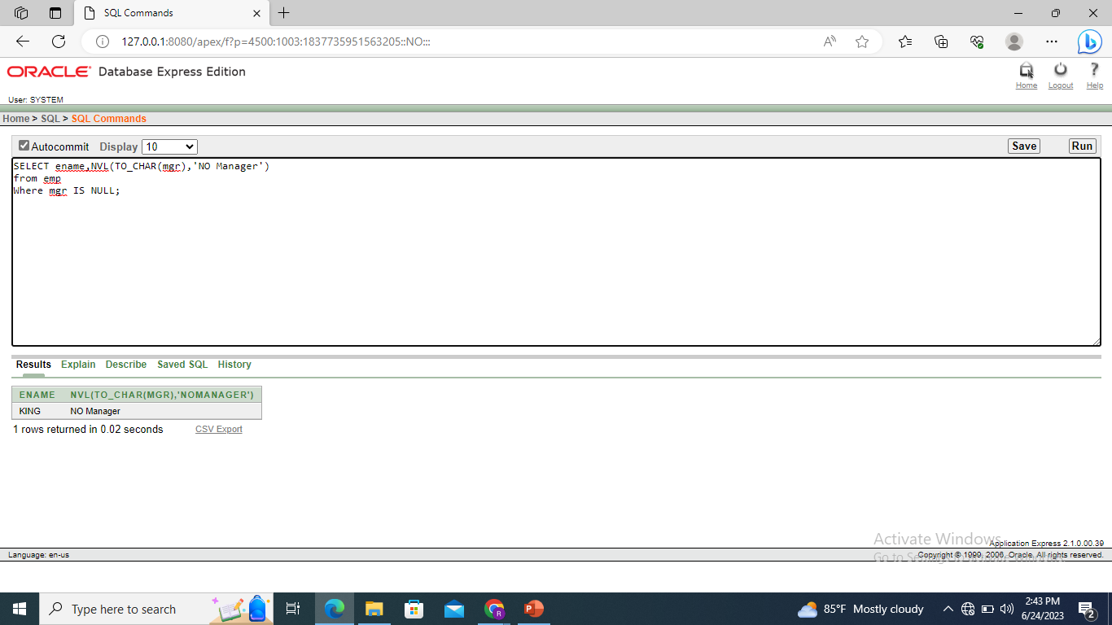

Select avg(sal),max(sal),min(sal),sum(sal) FROM emp WHERE job like ‘SALES%’;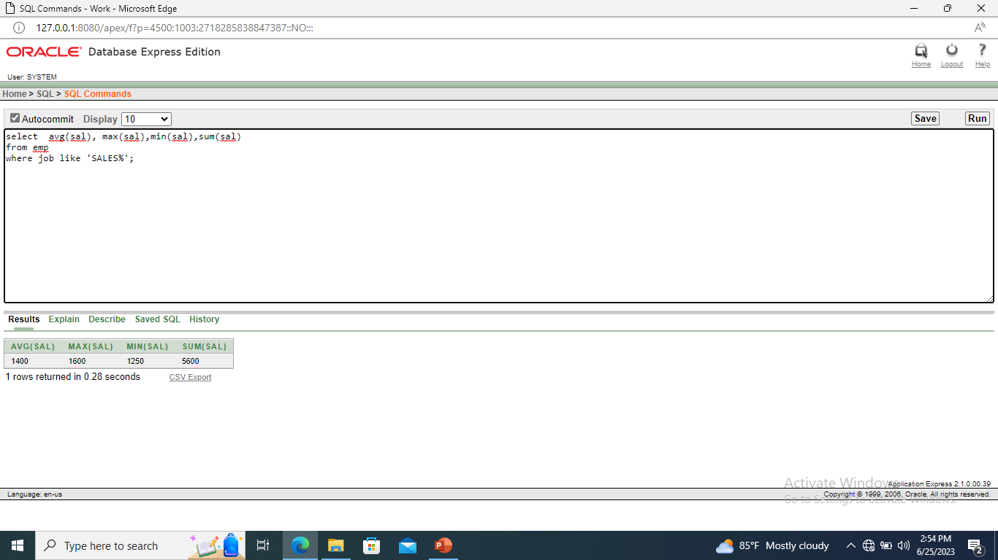

Select min(hiredate),max(hiredate) from emp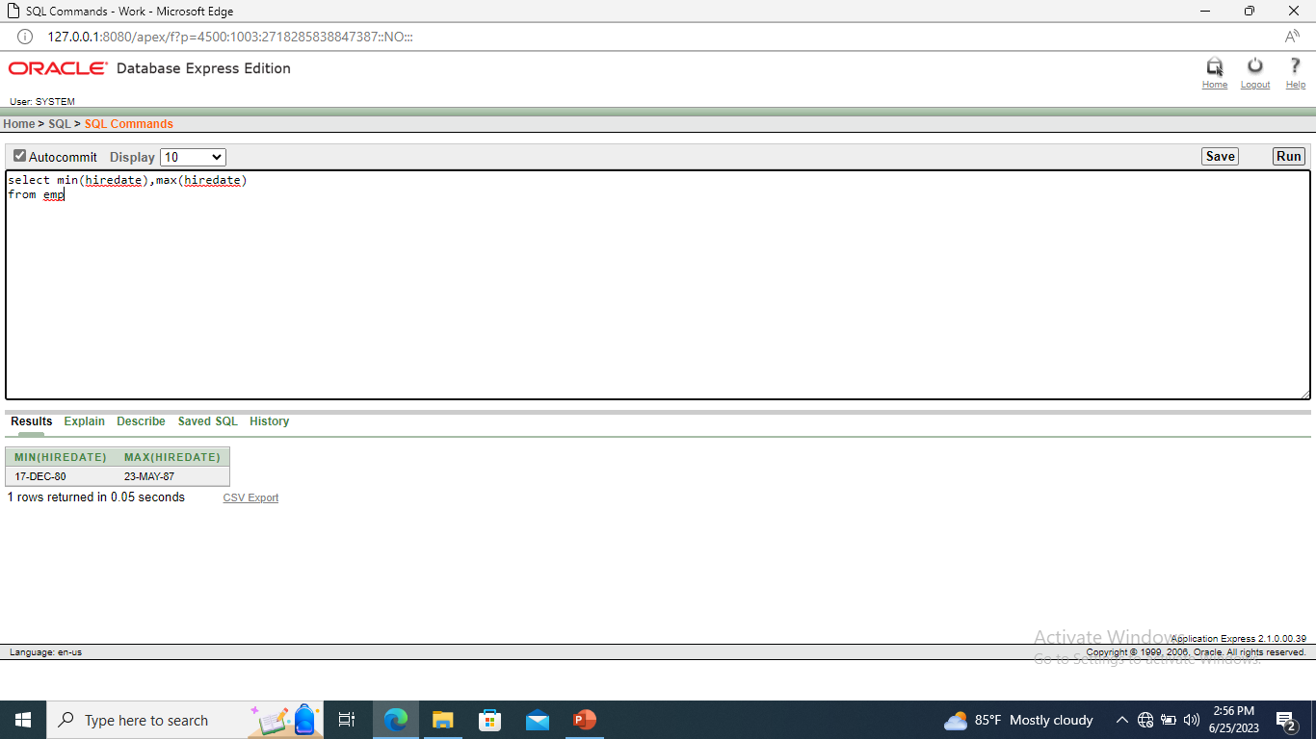

Select Count(*) from emp where deptno = 30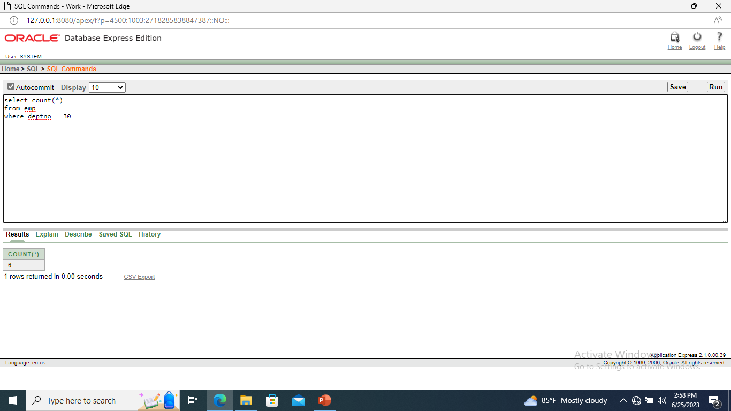

Select count (comm) from emp where deptno = 30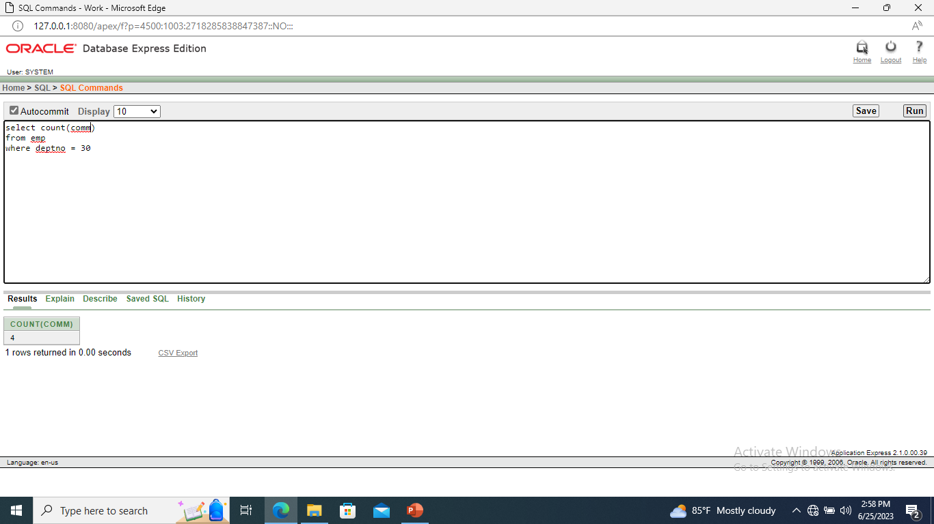

Select avg(comm) from emp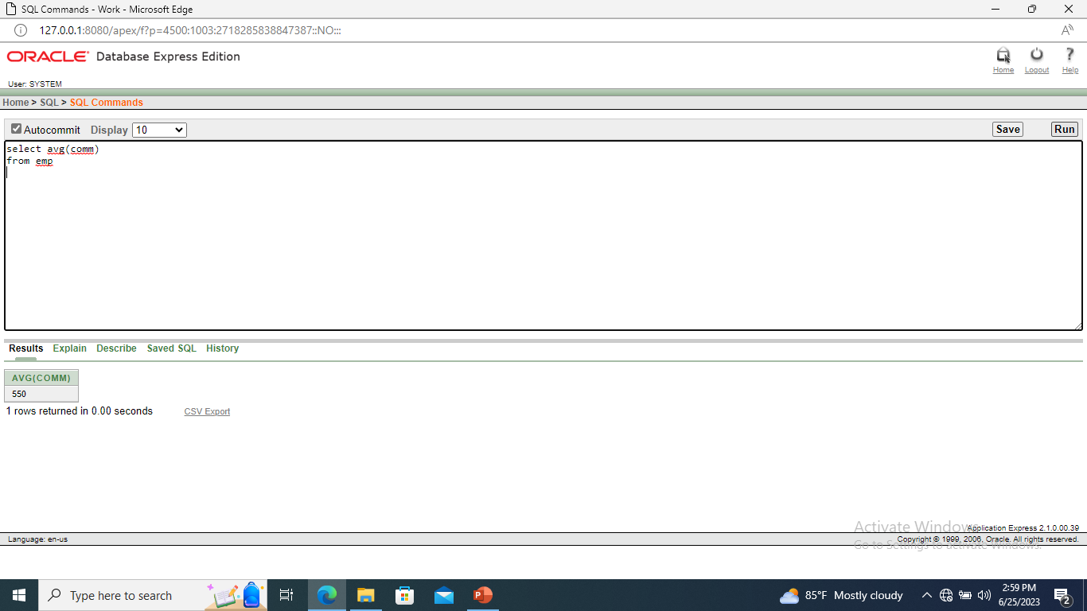

Selct avg (nvl(comm,0)) from emp;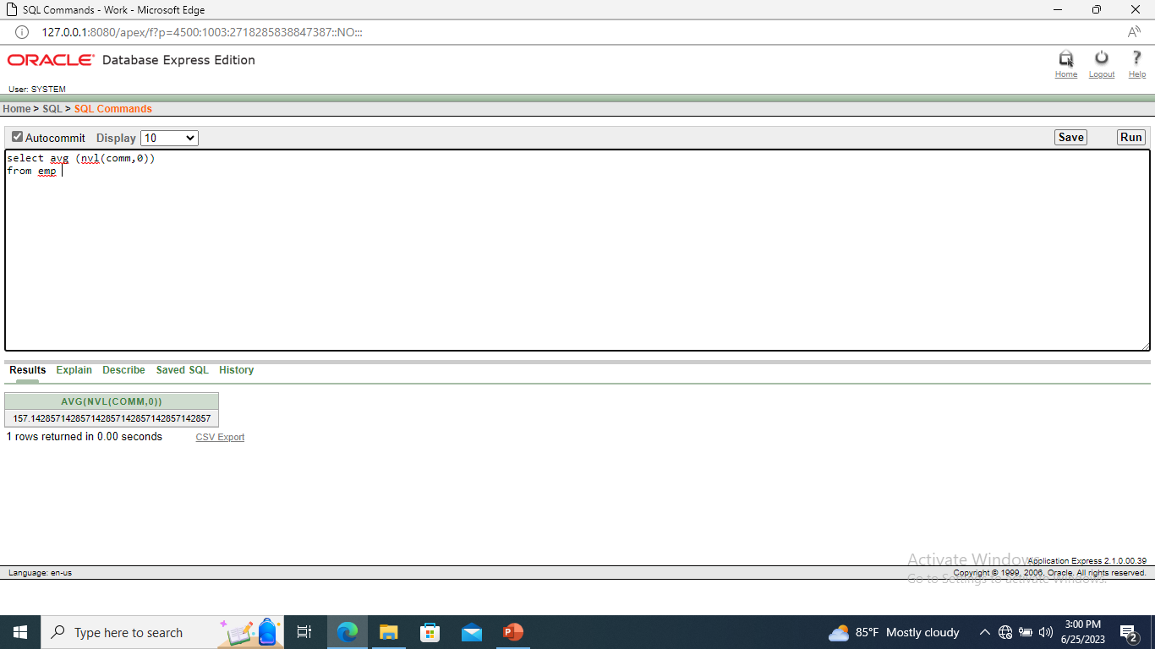

Select deptno,avg(sal) from emp group by deptno;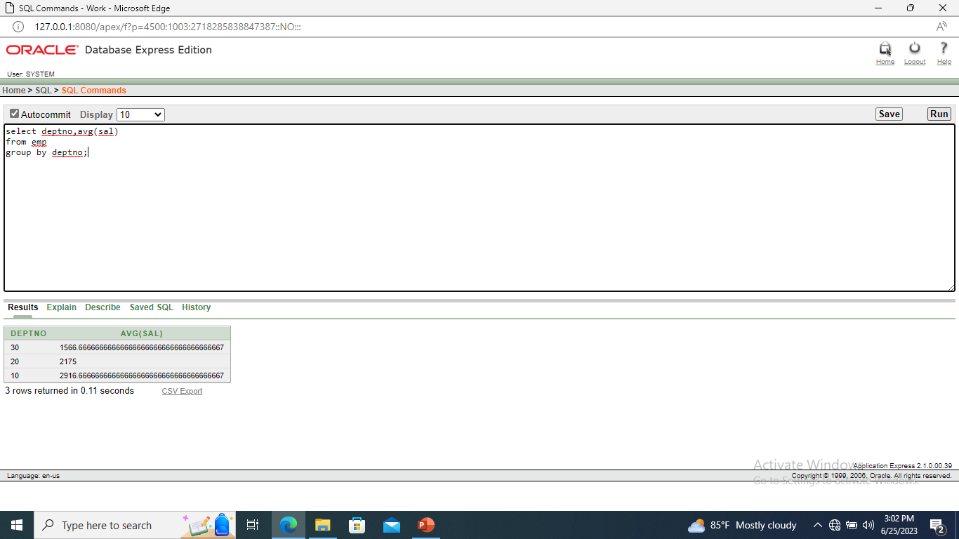

Select avg(sal) from emp group by deptno;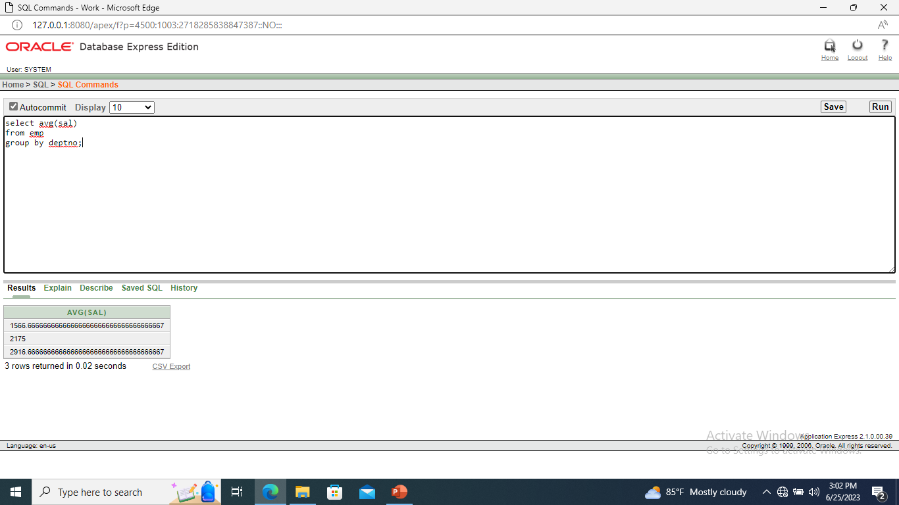

Select deptno,job,sum(sal) from emp group bydeptno,job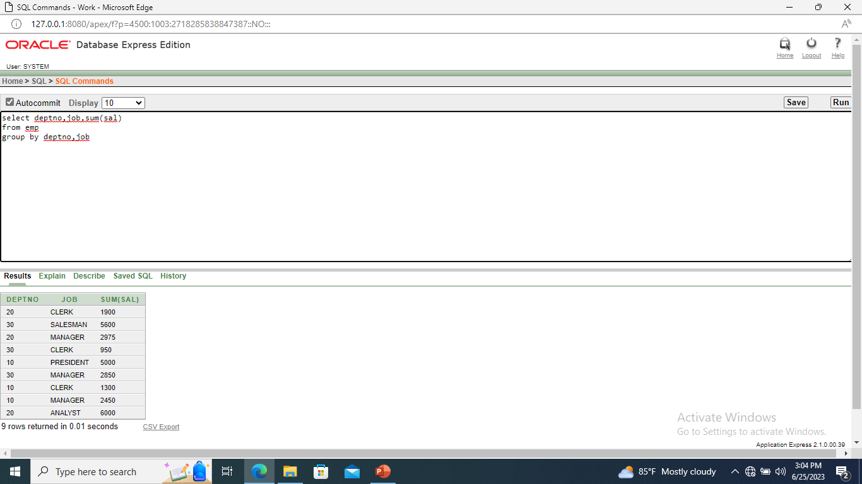

Select deptno,job,sum(sal) from emp group by deptno,job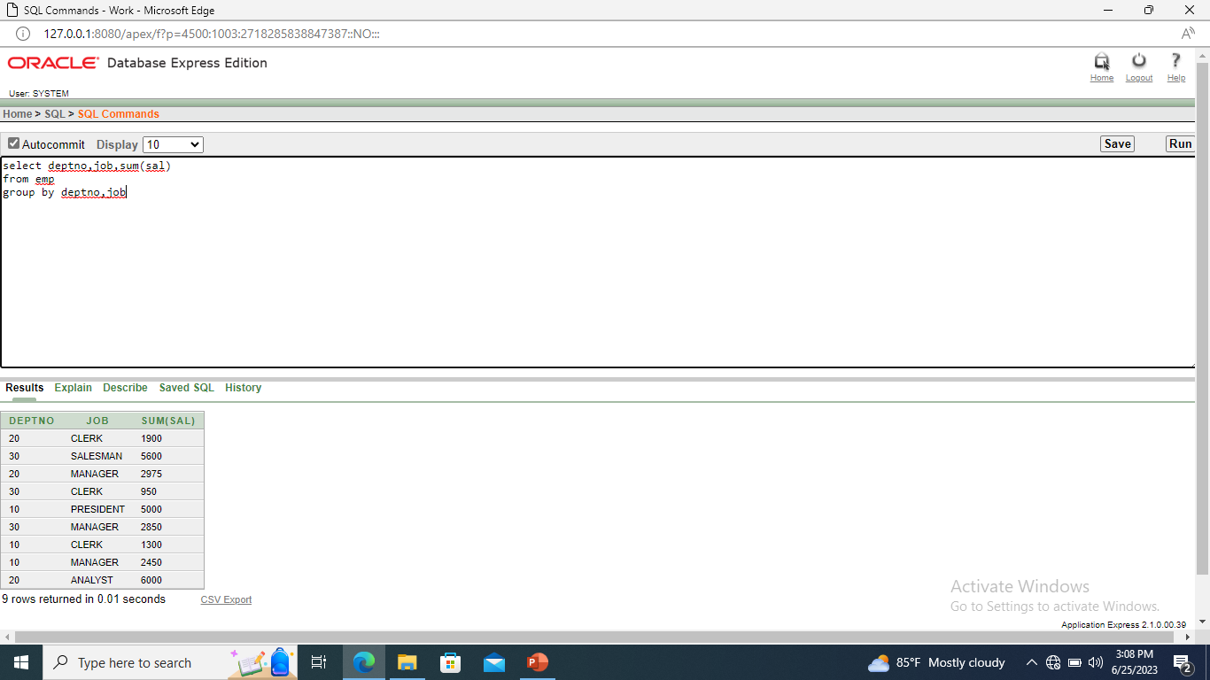

Select deptno,max(sal) from emp group by deptno Having max(sal)>2900;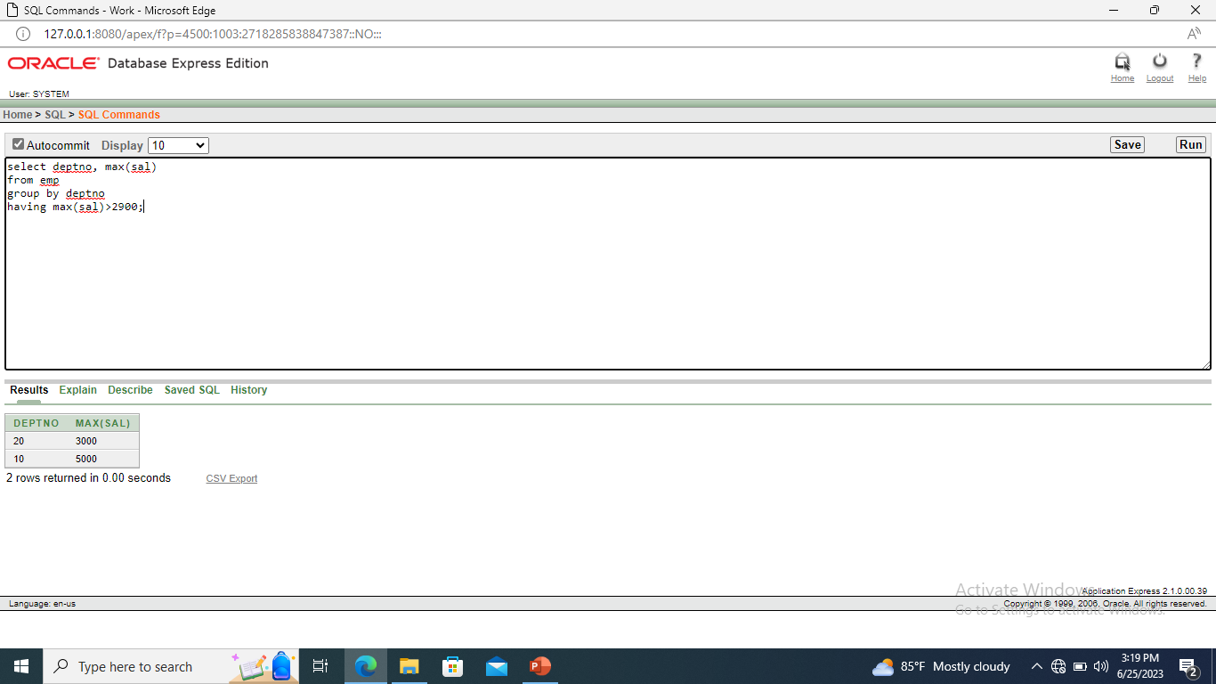

Select job,sum(sal) PAYROLL FROM emp where job not like ‘sales%’ group by job having sum(sal)>5000 order by sum(sal)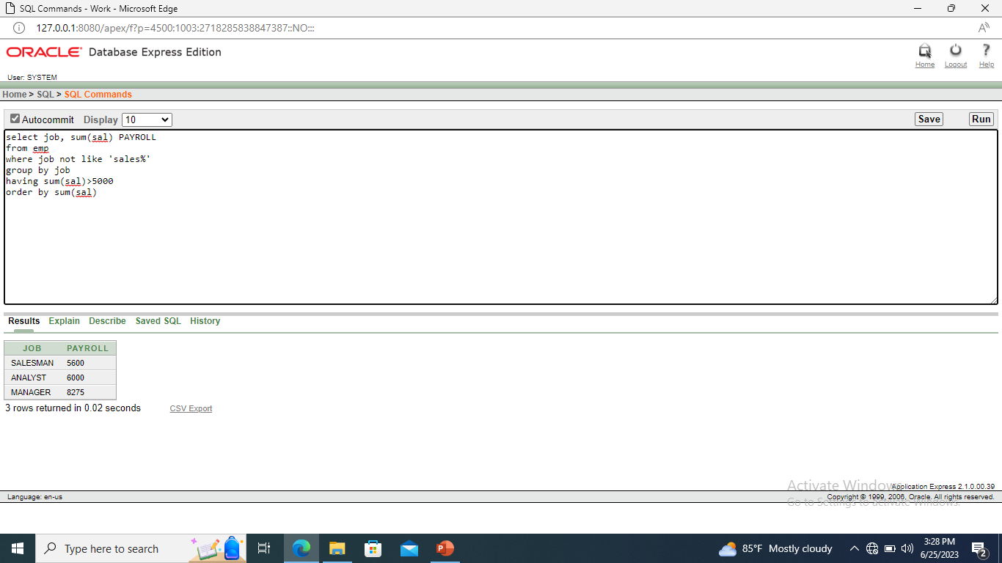

Select Max (avg(sal)) from emp group by deptno;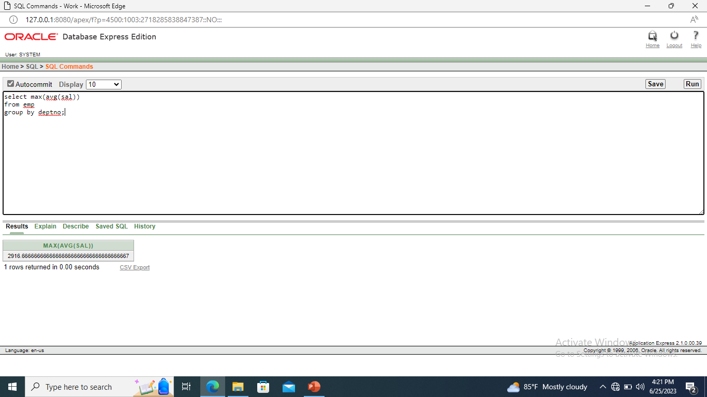

Select ename,job,deptno from emp where job=’CLERK’;